Screenshots of Sankey Cover Figures

Below are screenshots of the dashboards for the cover figure. One is when there is a monthly deficit, the other, a surplus. As noted in the documentation for the other figures, screens/monitors will affect text size, and this will need to be adjusted accordingly. The spacing can be controlled through the Python script and fonts sizes in Tableau.

# Cover Figure – Sankey – Deficit (Default Tableau text)

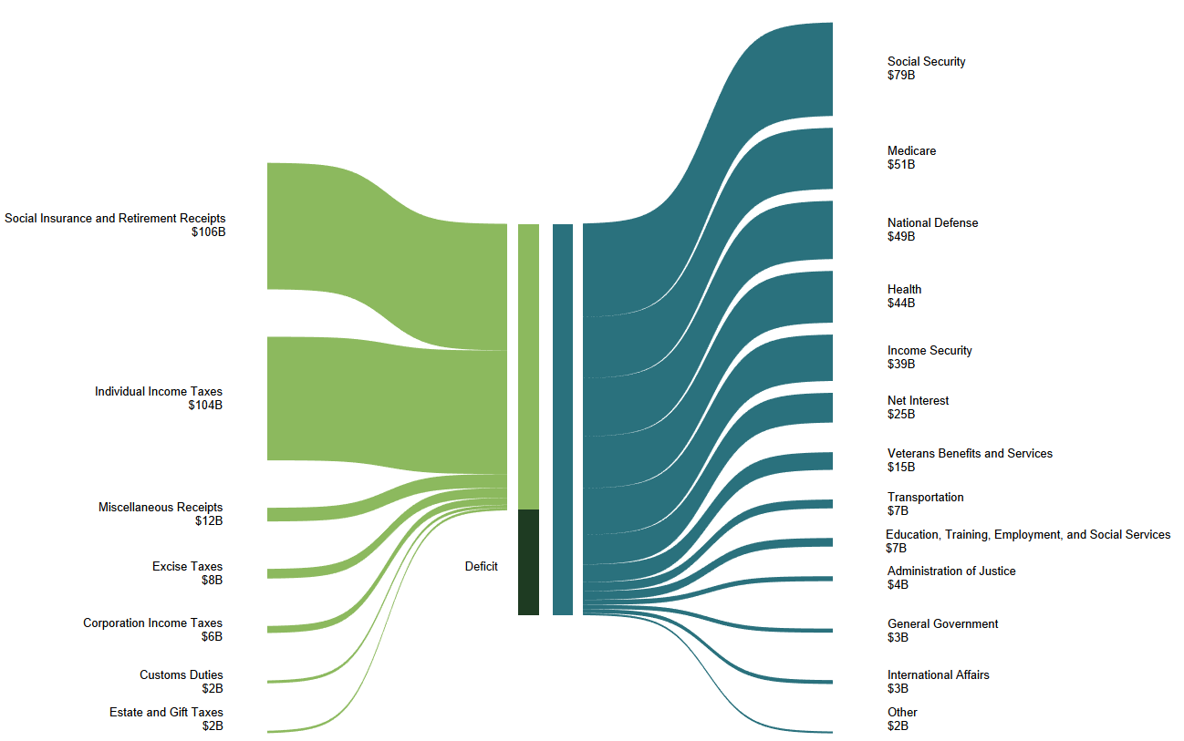

# Cover Figure – Sankey – Deficit (PowerPoint text)

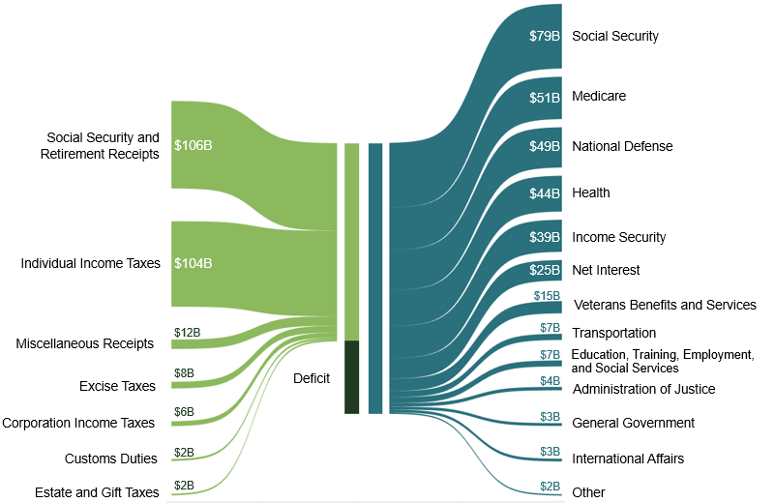

# Cover Figure – Sankey – Surplus